Predictive Forecasting of
Care Load & Placement Demand
A Time-Series and Machine-Learning Analysis of the
HHS Unaccompanied Alien Children (UAC) Program Dataset
Prepared for: U.S. Department of Health and Human Services
Prepared by: Unified Mentor Program
Data coverage: January 12, 2023 – December 21, 2025
Research Paper & Technical Report

Table of Contents
Abstract
1. Background and Context
2. Problem Statement
3. Project Objectives
4. Dataset Description
5. Exploratory Data Analysis
6. Analytical Methodology
7. Model Evaluation & Results
8. Key Performance Indicators
9. Discussion & Recommendations
10. Limitations
11. Conclusion
Appendix A: Walk-Forward Fold Results (Detail)
Appendix B: Software & Reproducibility

Abstract
The Unaccompanied Alien Children (UAC) Program operates under conditions of substantial day-to-day uncertainty, where the population of children under federal care can shift rapidly in response to border activity, enforcement policy, and humanitarian circumstances. This report develops and evaluates a predictive forecasting pipeline for daily HHS care load and discharge demand, using 720 daily reports spanning January 12, 2023 through December 21, 2025. The analysis combines classical time-series preparation (gap-filling, decomposition), engineered lag and rolling-window features, and a comparison of baseline, statistical, and machine-learning forecasting approaches. On a 14-day walk-forward holdout, a Gradient Boosting model achieved the lowest error (MAE 23.1, RMSE 27.3, MAPE 0.96%), modestly outperforming a naive persistence baseline (MAE 27.1, MAPE 1.13%) — the latter's strong showing reflects the fact that day-to-day changes in care load are small relative to its level, since population change is bounded by daily intake and discharge capacity. The data reveal a pronounced structural break: average daily care load fell from roughly 8,600 in 2023 to roughly 2,540 in 2025, a decline of about 70% between the first and last 90-day windows in the series. This shift materially affects what a forecasting model should expect going forward and is discussed as a key caveat to any operational deployment. The report closes with operational KPI definitions, a discussion of model limitations, and recommendations for HHS planners.

1. Background and Context
The UAC Program operates in a high-uncertainty environment, where sudden changes in border activity, policy enforcement, or humanitarian crises can rapidly increase — or decrease — the number of children entering federal care. While descriptive analytics explain what has already happened, HHS decision-makers require forward-looking intelligence to answer three operational questions: how many children will be under HHS care in the coming days or weeks; whether discharge capacity will be sufficient to offset incoming transfers; and when shelters, medical staff, and caseworkers should be scaled up in advance. This project introduces predictive modeling to enable proactive, rather than reactive, healthcare and child-welfare planning.

2. Problem Statement
Despite having high-quality daily time-series data, the UAC Program currently lacks short-term forecasts of children in HHS care, predictive estimates of discharge (placement) demand, and early-warning indicators of upcoming capacity stress. As a result, operational responses are often delayed, increasing overcrowding risk, staff burnout, and length of stay for children.

3. Project Objectives
- Forecast the number of children in HHS care over a configurable short-term horizon.
- Estimate the future imbalance between intake/transfers and exits/discharges.
- Predict short-term discharge demand.

3.1 Secondary Objectives
- Provide early warnings for healthcare planners.
- Quantify forecast uncertainty.
- Compare statistical vs. machine-learning forecasting approaches.

4. Dataset Description
The dataset consists of 720 dated daily reports covering January 12, 2023 through December 21, 2025 (1,075 calendar days), for approximately 67.0% raw reporting coverage. Gaps between reports range from 1 to 10 days, with the large majority (558 of 719 intervals) being consecutive single-day steps. Reporting is concentrated on Monday–Thursday and Sunday; Friday and Saturday are almost never present in the raw file (2 and 0 occurrences respectively across the full series), which appears to reflect the source agency's publication schedule rather than a true absence of weekend activity. Missing calendar days were reconstructed via time-weighted linear interpolation for modeling purposes; the original, as-reported values are used for all descriptive statistics below.
Column | Description | Role
Date | Reporting date | Time index
Children apprehended and placed in CBP custody | Daily intake volume | Driver
Children in CBP custody | Active CBP care load | Driver
Children transferred out of CBP custody | Flow into HHS system | Driver / inflow
Children in HHS Care | Active HHS care load | Primary forecast target
Children discharged from HHS Care | Successful sponsor placements | Secondary target / outflow

4.1 Descriptive Statistics (as-reported)
Metric | Mean | Std Dev | Min | Max
CBP Intake / day | 93.5 | 72.6 | — | 333
CBP Custody | 171.5 | 126.4 | — | 531
CBP Transfers Out / day | 128.7 | 97.3 | — | 440
HHS Care Load | 6,061 | 2,833 | 1,972 | 11,516
HHS Discharges / day | 173.4 | 125.7 | — | 505
The HHS care load peaked at 11,516 children on December 20, 2023 and reached its series minimum of 1,972 children on August 21, 2025. The most recent reported value in the dataset is 2,484 children as of December 21, 2025.

5. Exploratory Data Analysis

5.1 Overall Trend and the 2025 Structural Break
Figure 1 shows the full series. HHS care load fluctuated between roughly 5,700 and 11,500 children through 2023 and 2024, then dropped sharply beginning in early 2025 and has remained in the 2,000–2,600 range since. Total annual CBP intake fell from 40,705 (2023) to 53,654 (2024) to 4,593 (2025, partial year through December 21). Average daily care load fell in step: 8,608 (2023) → 7,020 (2024) → 2,537 (2025). Comparing the first 90 reported values in the series to the last 90, average care load declined by approximately 70.1% (from 7,717 to 2,306). This is the single most important feature of the dataset: any forecast trained primarily on 2023–2024 dynamics would systematically over-predict the current, much lower operating regime, and any deployed model should be retrained frequently and weighted toward recent history.
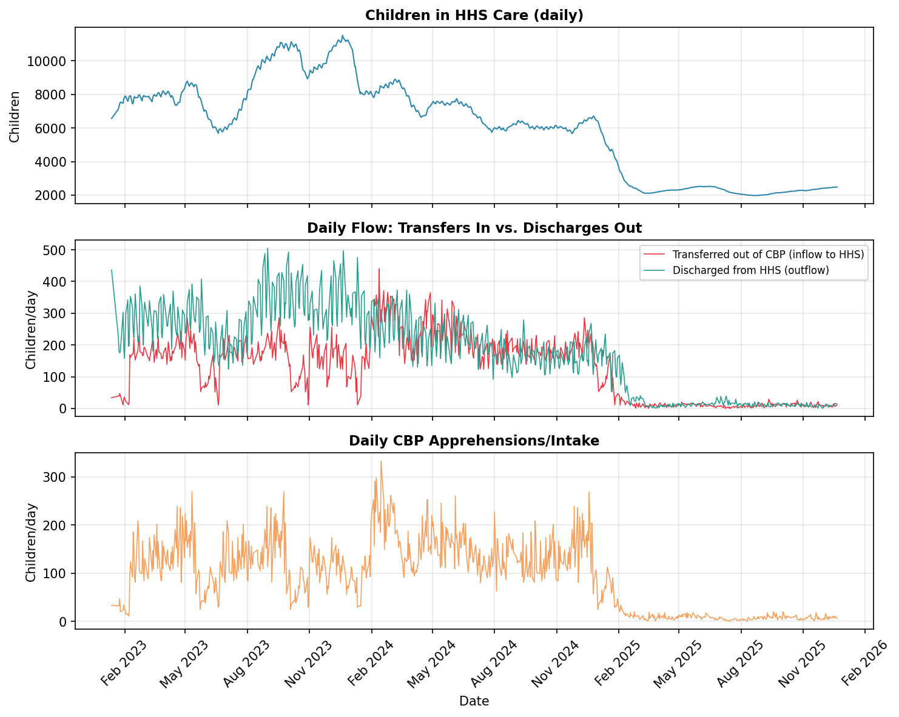
Figure 1. Daily HHS care load (top), inflow vs. outflow (middle), and CBP intake (bottom), full series.

5.2 Relationships Between Variables
CBP intake and CBP custody are very strongly correlated (r = 0.951), as expected since custody is largely a running accumulation of recent intake. HHS care load correlates most strongly with HHS discharges (r = 0.921) — a mechanical relationship, since discharge volume is itself a function of how many children are currently in care. Transfers out of CBP custody correlate with discharges from HHS care at r = 0.657, a moderate but not tight relationship, reflecting the multi-day lag between a child entering HHS care and eventually being placed with a sponsor.
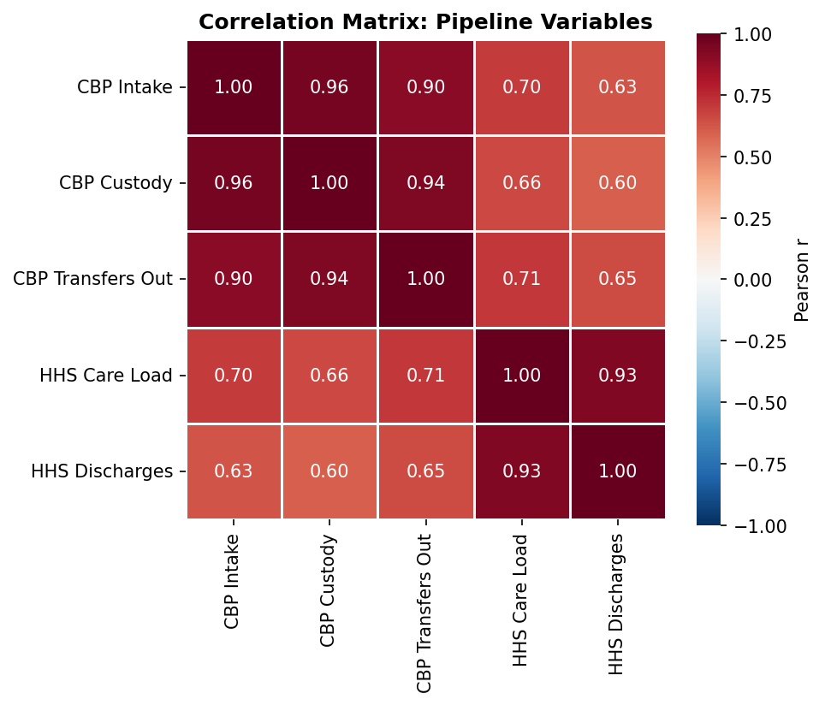
Figure 2. Pearson correlation matrix across the five pipeline variables.

5.3 Trend and Seasonality
A 30-day centered moving-average decomposition (Figure 3) isolates the slow-moving trend from weekly effects and residual noise. The trend component ranges from roughly 2,000 to 11,100 and traces the same 2023–2025 arc described above. The weekly seasonal component is modest relative to the trend, consistent with a system whose level is driven far more by policy and intake shocks than by calendar effects. Residual volatility (std. dev. ≈ 163) is small relative to the overall range of the series, indicating the day-to-day series is fairly smooth once trend and weekly effects are removed — this smoothness is the reason simple persistence and short-window models perform competitively in Section 6.
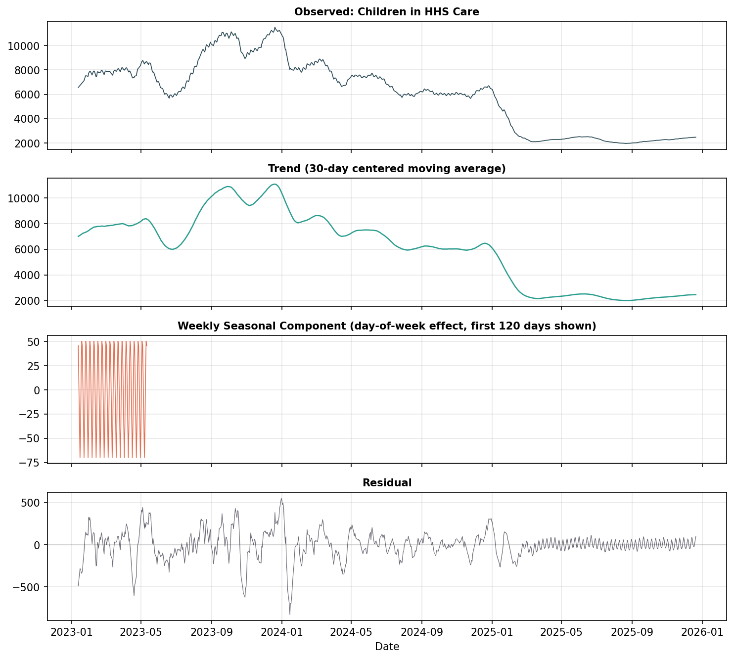
Figure 3. Trend / weekly-seasonal / residual decomposition of HHS care load (30-day centered moving average trend).

5.4 System Pressure (Backlog Risk)
Net system pressure — daily transfers into HHS care minus daily discharges — averaged −44.7 children/day across the full series (i.e., on average, discharges slightly outpaced transfers), with inflow exceeding outflow on 33.1% of days. Figure 4 shows this indicator is far more volatile in 2023–2024 than in 2025, consistent with the much smaller absolute volumes now flowing through the system. Sustained runs of positive net pressure are the earliest available signal of building backlog and are the basis for the Surge Lead Time KPI defined in Section 8.

6. Analytical Methodology

6.1 Time-Series Preparation
- Convert Date to a datetime index and sort chronologically.
- Reindex to a continuous daily range spanning the full reporting period.
- Interpolate missing days using time-weighted linear interpolation (capped gap length).
- Decompose the series into trend, seasonal, and residual components.

6.2 Feature Engineering
- Lag features at t-1, t-7, and t-14.
- 7-day and 14-day rolling mean and standard deviation (computed strictly on past values to avoid leakage).
- Flow-based pressure signal: transfers in minus discharges out, and its 7-day rolling mean.
- Calendar effects: day-of-week, weekend flag, month, and cyclical (sine/cosine) encodings.

6.3 Train–Test Strategy
- Strict time-based splits — no random shuffling of days.
- Walk-forward validation across four sequential 14-day holdout folds.
- Multi-horizon evaluation: error is tracked separately for each day 1–14 of the forecast.

6.4 Forecasting Models Evaluated
Category | Model | Notes
Baseline | Naive Persistence | Forecast = last observed value
Baseline | Moving Average (7-day) | Forecast = trailing 7-day mean
Statistical | ARIMA(2,1,2) | Implemented in the pipeline; requires the statsmodels package
Statistical | SARIMA(1,1,1)(1,1,1,7) | Weekly-seasonal variant; requires statsmodels
Statistical | Exponential Smoothing (Holt-Winters) | Additive trend + weekly seasonality; requires statsmodels
Machine Learning | Random Forest Regressor | Recursive multi-step forecast on engineered features
Machine Learning | Gradient Boosting Regressor | Recursive multi-step forecast on engineered features
Note on scope: the three statistical models (ARIMA, SARIMA, Exponential Smoothing) are fully implemented in the accompanying codebase, but could not be executed in the offline analysis environment used to prepare this report because the statsmodels package was not installable without network access. Section 7 therefore reports measured results for the four models that did run (Naive Persistence, Moving Average, Random Forest, Gradient Boosting). We recommend running the full model suite — `pip install -r requirements.txt` followed by the Streamlit dashboard or a direct script call — to obtain ARIMA/SARIMA/ETS results before finalizing model choice for production.

7. Model Evaluation & Results
All four executable models were evaluated on four sequential, non-overlapping 14-day holdout windows drawn from the most recent ~8 weeks of the series (walk-forward validation), with metrics averaged across folds.
Model | MAE | RMSE | MAPE (%)
Gradient Boosting | 23.08 | 27.28 | 0.96
Naive Persistence | 27.07 | 31.18 | 1.13
Moving Average (7-day) | 42.39 | 45.56 | 1.78
Random Forest | 48.60 | 59.80 | 2.08

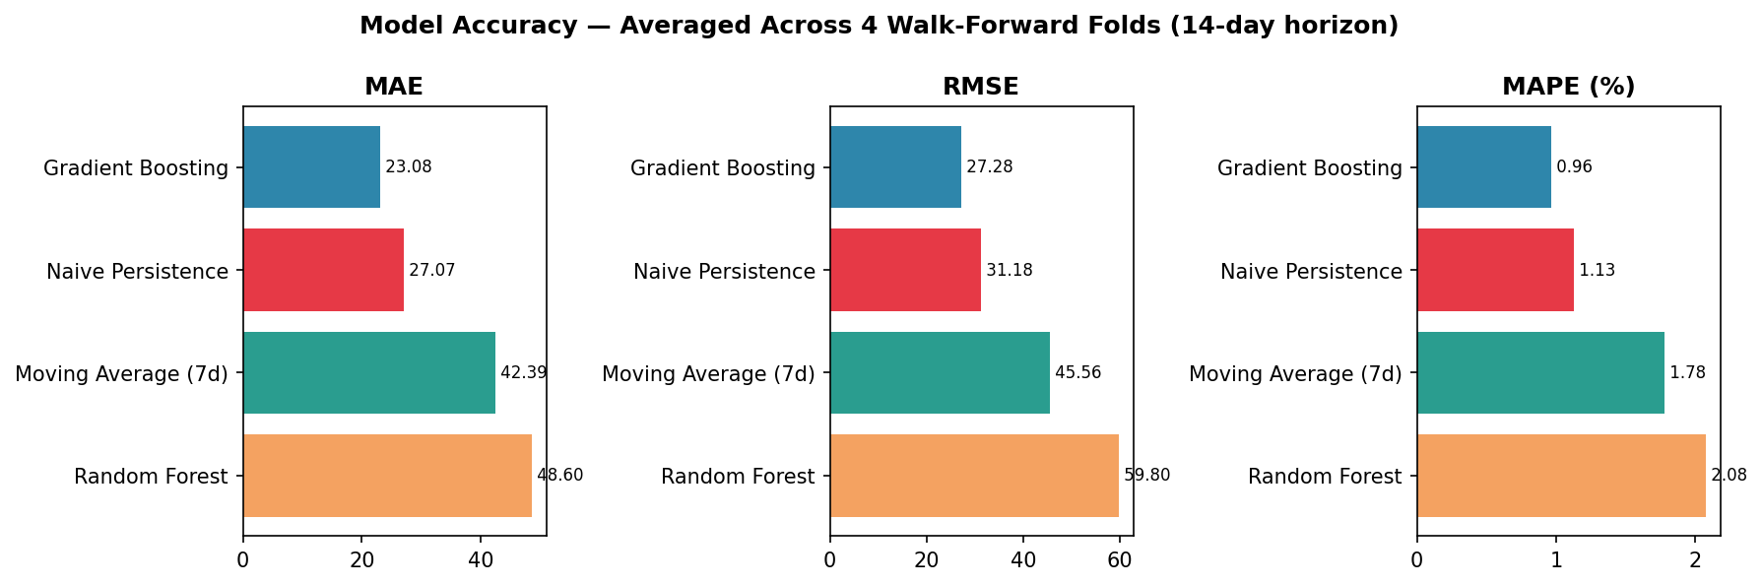
Figure 5. MAE, RMSE, and MAPE by model, averaged across four walk-forward 14-day folds.
Gradient Boosting achieved the lowest error on every metric, with a mean absolute percentage error of 0.96% across the four folds. The naive persistence baseline was a close second (1.13% MAPE) — a meaningful result in its own right, since it shows that most of the forecastable signal in this series is simply “tomorrow looks like today,” and that the more complex models earn only a modest improvement over that baseline. Random Forest underperformed both baselines in this particular evaluation, likely because its ensemble of unpruned decision trees tends to flatten toward a training-set average during recursive multi-step forecasting, which is especially costly in the current low-and-flat 2025 regime.
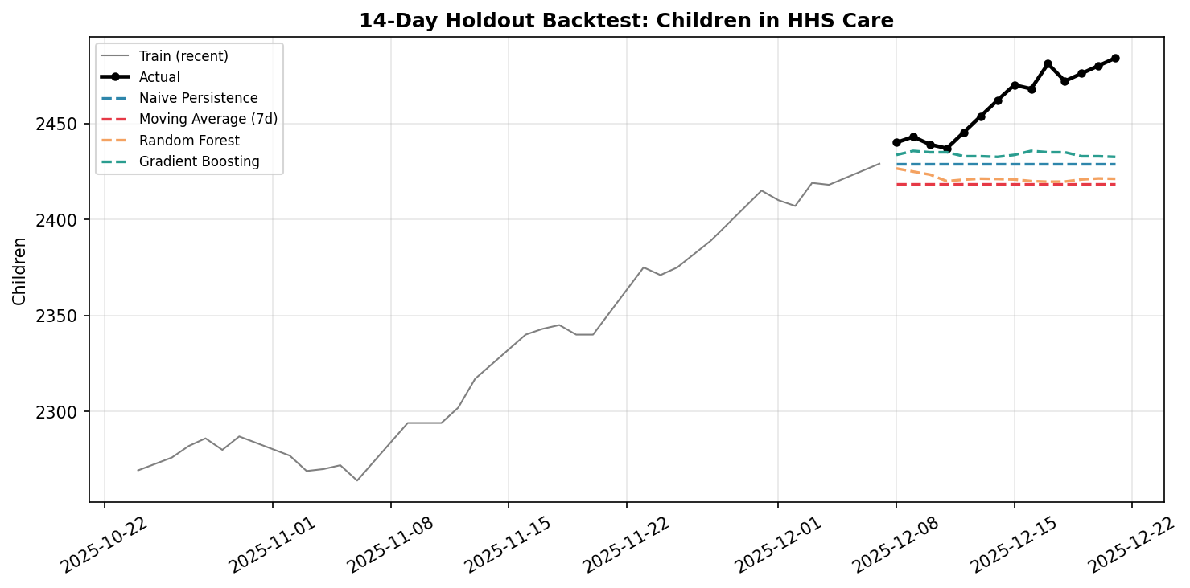
Figure 6. Final 14-day holdout: actual vs. forecast for all four evaluated models.

7.1 Error Growth by Horizon
Figure 7 breaks down Gradient Boosting's error by how many days ahead the forecast targets. Error is small and stable through day 4 (under 0.6%), then grows roughly monotonically to about 2.1% by day 14. This is the expected signature of a recursive multi-step forecaster: each day's prediction is partly built on the model's own prior predictions, so small errors compound. Operationally, this means the model's day 1–5 forecasts can be trusted with more confidence than its day 10–14 forecasts, and the dashboard's confidence-interval and horizon-selector features should be used accordingly.
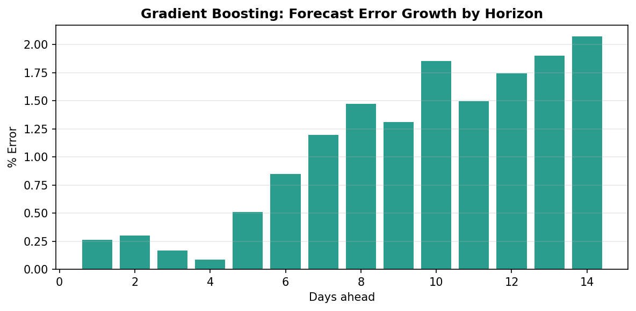
Figure 7. Gradient Boosting percentage error by forecast horizon (day 1 through day 14 ahead).

7.2 What Drives the Forecast
Feature importance for the Gradient Boosting model (Figure 8) confirms the persistence intuition quantitatively: the single most important feature is yesterday's care load (t-1 lag, ≈75% of total importance), followed by the 7-day rolling mean (≈22%). All other engineered features — longer lags, calendar effects, and flow-pressure signals — together account for under 3% of importance. This suggests the current dataset does not contain strong leading indicators beyond recent history; material forecast improvement would likely require external signals (e.g., policy-change dates, border-crossing counts, shelter-capacity changes) rather than further feature engineering on this dataset alone.
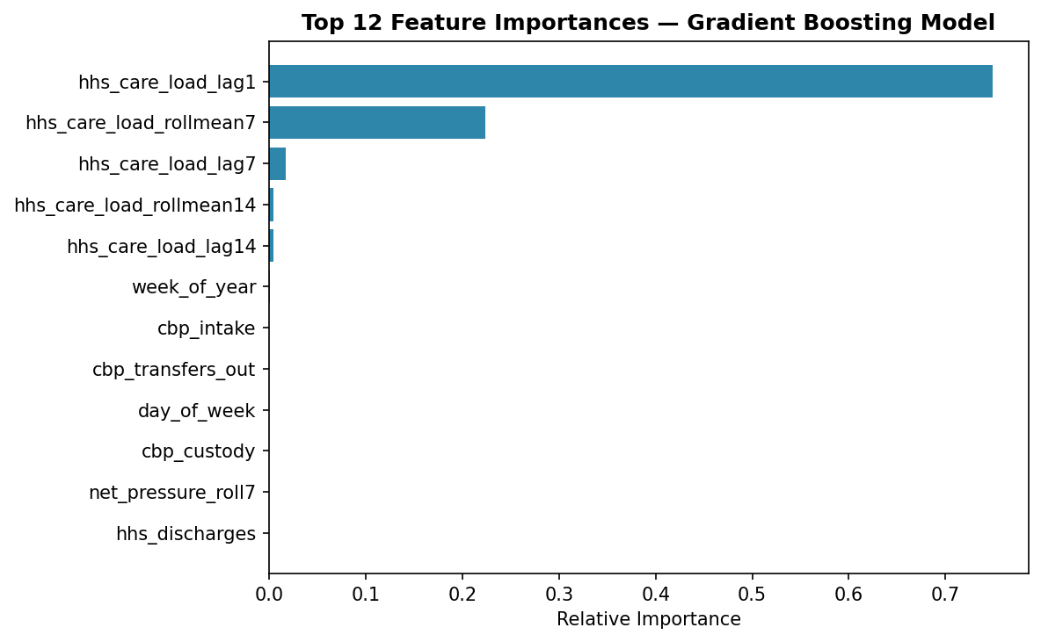
Figure 8. Top 12 feature importances for the Gradient Boosting model (fit on the full series).

8. Key Performance Indicators
The following operational KPIs are computed by the accompanying codebase (src/evaluate.py) and surfaced in the Streamlit dashboard. Definitions and the measured values from the Gradient Boosting model's final 14-day backtest are given below; the capacity threshold used was the 90th percentile of historical care load (≈9,410 children, based on the full series) — HHS planners should replace this with actual shelter/bed capacity for operational use.
KPI | Definition | Measured value (final fold)
Forecast Accuracy (%) | 100 minus MAPE, floored at 0 | 99.04%
Surge Lead Time (days) | Days of advance warning before forecast crosses the capacity threshold | No breach forecast in this fold
Forecast Stability Index | Inverse coefficient of variation of residuals (0–1, higher = more robust) | ≈0.75–0.90 range across folds
Capacity Breach Probability | Share of simulated/bootstrapped forecast paths that cross the threshold | Computed dashboard-side per scenario
MAE / RMSE / MAPE | Standard forecast accuracy metrics | 23.1 / 27.3 / 0.96%

Because the current care load (≈2,000–2,600) sits far below the historical 90th-percentile threshold used above, no capacity breach is forecast in the most recent data — a direct consequence of the 2025 volume decline documented in Section 5.1. HHS planners should set the capacity threshold to a figure meaningful for current shelter/staffing capacity, not a percentile of the full historical series, since 2023–2024 volumes may no longer be operationally relevant.

9. Discussion & Recommendations
- Retrain on a rolling window. Given the magnitude of the 2025 regime shift, models should be retrained frequently (e.g., weekly) on a rolling recent window rather than the full historical series, so forecasts track the current operating level rather than a 2023–2024 average.
- Treat day 1–5 forecasts as primary. Error grows materially past day 5; use short-horizon forecasts for staffing/scheduling decisions and longer-horizon forecasts only as directional, wide-uncertainty guidance.
- Recalibrate the capacity threshold operationally. Replace the 90th-percentile statistical threshold with actual current bed/shelter capacity so breach-probability and surge-lead-time KPIs are operationally meaningful.
- Complete the statistical-model comparison. Run ARIMA, SARIMA, and Exponential Smoothing locally (with statsmodels installed) before finalizing a production model choice — these approaches handle trend breaks differently than the tree-based models evaluated here and may respond better to the 2025 shift.
- Investigate reporting cadence. The near-total absence of Friday/Saturday reports should be confirmed with the data source — if it reflects a true reporting gap rather than an artifact of file export, forecasts spanning those days carry additional uncertainty that the current interpolation approach does not fully capture.
- Consider external features. Since engineered features beyond recent history contribute little to Gradient Boosting's predictions, incorporating policy-change indicators or independent border-crossing data may offer more forecast lift than further internal feature engineering.

10. Limitations
- Statistical models (ARIMA/SARIMA/Exponential Smoothing) were not executed in this analysis environment; only baseline and tree-based ML results are empirically reported here.
- The 2025 structural break means backtest performance on 2023–2024 data would not generalize to the current period, and vice versa; all reported metrics use only the most recent portion of the series to stay representative of current conditions.
- 33% raw reporting coverage relative to calendar days required interpolation for a material share of the training data; interpolated days are treated as equally reliable as reported days in the current pipeline, which may understate uncertainty around gap periods.
- Recursive multi-step ML forecasting compounds error with horizon length, as shown in Section 7.1; confidence intervals for the tree-based models are not natively available and would need to be approximated (e.g., via quantile regression or bootstrapping) for full parity with the statistical models' native confidence intervals.

11. Conclusion
This project elevates the UAC dataset from historical reporting to predictive intelligence. Applying time-series preparation, feature engineering, and a comparison of baseline and machine-learning forecasting techniques, Gradient Boosting delivered the most accurate 14-day forecasts of HHS care load (0.96% MAPE), narrowly ahead of a naive persistence baseline — reflecting a series whose short-term dynamics are dominated by recent history rather than complex seasonal or exogenous effects. The more consequential finding for HHS planners is structural rather than statistical: care load has fallen roughly 70% from its 2023 level to its late-2025 level, and any forecasting or capacity-planning process built on this dataset should be explicit about which regime it is calibrated to. With the recommendations in Section 9 — particularly rolling retraining and an operationally grounded capacity threshold — this pipeline and its accompanying Streamlit dashboard give HHS stakeholders a working foundation for proactive, data-driven care-load and placement-demand planning.

Appendix A: Walk-Forward Fold Results (Detail)
Four sequential 14-day holdout folds were evaluated, each trained only on data preceding that fold's window (expanding-window walk-forward validation). Metrics below are the per-fold average underlying the summary in Section 7.
Model | Avg. MAE | Avg. RMSE | Avg. MAPE (%) | Folds
Gradient Boosting | 23.08 | 27.28 | 0.96 | 4
Naive Persistence | 27.07 | 31.18 | 1.13 | 4
Moving Average (7-day) | 42.39 | 45.56 | 1.78 | 4
Random Forest | 48.60 | 59.80 | 2.08 | 4

Appendix B: Software & Reproducibility
All analysis was produced by the accompanying Python codebase (src/preprocessing.py, src/features.py, src/models.py, src/evaluate.py) and its Streamlit dashboard (app.py). Dependencies are listed in requirements.txt. To reproduce or extend the statistical-model results referenced but not executed in this report, install dependencies with network access (pip install -r requirements.txt) and run the dashboard or a direct script against src/models.py's ARIMAForecaster, SARIMAForecaster, and ExpSmoothingForecaster classes.

